SYDNEY WESTERN CITY PLANNING PANEL

Panel No: | 2019WCI004.
DA Number: | 2018/1435/1.
Local Government Area: | Camden.
Development: | Torrens title subdivision to create 123 residential lots, 1 public reserve lot, construction of 8 dwelling house, 97 attached dwellings and 18 semi-detached dwellings with 8 secondary dwellings, construction of laneways and shared driveways, earthworks, landscaping and associated works.
Street Address(es): | 600B The Northern Road, Oran Park.  11 Civic Way, Oran Park.  60 Madden Street, Oran Park.
Applicant: | Villa World Developments Pty Ltd.
Owner: | Leppington Pastoral Co Pty Ltd.
Date of DA Lodgement: | 10 December 2018.
Number of Submissions: | No submissions received.
Recommendation: | Approve with conditions.
Regional Development Criteria (Schedule 7 of State Environmental Planning Policy (State and Regional Development) 2011): | General development capital investment value >$30 million.
List of All Relevant s4.15(1)(a) Matters: | - State Environmental Planning Policy (State and Regional Development) 2011.  - State Environmental Planning Policy (Sydney Region Growth Centres) 2006.  - State Environmental Planning Policy No 55 - Remediation of Land.  - State Environmental Planning Policy (Building Sustainability Index: BASIX) 2004.  - State Environmental Planning Policy (Affordable Rental Housing) 2009.  - Sydney Regional Environmental Plan No 20 - Hawkesbury-Nepean River.  - Camden Development Control Plan 2011.  - Oran Park Precinct Development Control Plan 2007.
List all Documents Submitted with this Report for the Panel’s Consideration: | - Assessment report.  - State Environmental Planning Policy (Sydney Region Growth Centres) 2006 assessment table.  - Camden Development Control Plan 2011 assessment table.  - Oran Park Precinct Development Control Plan 2007 assessment table.  - Recommended conditions.  - Proposed plans.
Report Prepared By: | Jordan Soldo, Senior Town Planner.
Report Date: | November 2019.

Summary of Section 4.15 matters

Have all recommendations in relation to relevant s4.15 matters been summarised in the Executive Summary of the assessment report? | Yes.

Legislative Clauses Requiring Consent Authority Satisfaction

Have relevant clauses in all applicable environmental planning instruments where the consent authority must be satisfied about a particular matter been listed and relevant recommendations summarised in the Executive Summary of the assessment report? | Yes.

Clause 4.6 Contraventions to Development Standards

If a written request for a contravention to a development standard (clause 4.6 of the Growth SEPP) has been received, has it been attached to the assessment report? | N/A.

Special Infrastructure Contributions

Does the DA require Special Infrastructure Contributions (s7.24)? | Yes.

Conditions

Have draft conditions been provided to the applicant for comment? | Yes.

PURPOSE OF REPORT

The purpose of this report is to seek the Sydney Western City Planning Panel’s (the Panel’s) determination of a development application (DA) for an integrated housing development at 600B The Northern Road, 11 Civic Way, and 60 Madden Street, Oran Park.

The Panel is the consent authority for this DA as the capital investment value (CIV) of the development is $43.3 million. This exceeds the CIV threshold of $30 million for Council to determine the DA pursuant to Schedule 7 of State Environmental Planning Policy (State and Regional Development) 2011.

SUMMARY OF RECOMMENDATION

That the Panel determine DA/2018/1435/1 for an integrated housing development pursuant to Section 4.16 of the Environmental Planning and Assessment Act 1979 by granting consent subject to the conditions attached to this report.

EXECUTIVE SUMMARY

Council is in receipt of a DA for an integrated housing development at 600B The Northern Road, 11 Civic Way, and 60 Madden Street, Oran Park.

The DA has been assessed against the Environmental Planning and Assessment Act 1979, the Environmental Planning and Assessment Regulation 2000, relevant environmental planning instruments, development control plans and policies.

A summary of the assessment of all relevant environmental planning instruments is provided below with a detailed assessment provided later in the report.

State Environmental Planning Policy (State and Regional Development) 2011. | The Panel is the determining authority for this DA as the development has a CIV of $43.3 million which exceeds the CIV threshold of $30 million for Council to determine the DA.
State Environmental Planning Policy (Sydney Region Growth Centres) 2006. | The development is permitted with consent in the applicable R1 General Residential and R3 Medium Density Residential zones, is consistent with the zone’s objectives and generally compliant with the other matters for consideration.
State Environmental Planning Policy No 55 - Remediation of Land. | A summary of contamination assessment letter was prepared that identifies two existing contamination assessments and two site audit statements/reports covering the development site. The letter concludes that the site is suitable, from a contamination perspective, for the proposed residential land use.
State Environmental Planning Policy (Building Sustainability Index: BASIX) 2004 | Satisfactory BASIX certificates have been provided for each dwelling. A condition of consent has been included to ensure the development is carried out in accordance with the recommendations of the certificates.
State Environmental Planning Policy (Affordable Rental Housing) 2009 | The proposal is consistent with the relevant aims and requirements of the SEPP. All of the eight secondary dwellings comply with the maximum gross floor area standard.
Sydney Regional Environmental Plan No 20 - Hawkesbury-Nepean River (SREP 20). | The proposed development is consistent with the aim of the SREP (to protect the environment of the Hawkesbury-Nepean River system) and all of its planning controls.

The DA was publicly exhibited for a period of 14 days in accordance with Camden Development Control Plan 2011. The exhibition period was from 16 to 29 January 2019. No submissions were received.

The development has been assessed against State Environmental Planning Policy (Sydney Region Growth Centres) 2006 (Growth Centres SEPP), Camden Development Control Plan 2011 (Camden DCP) and the Oran Park Precinct Development Control Plan 2007 (Oran Park DCP). The development is generally consistent with these planning policies and controls in that it will contribute to providing a variety of housing types and densities to meet the housing needs of the community.

The applicant has submitted a traffic report in support of the DA. The traffic report demonstrates that the development will not have a significant negative impact upon the surrounding road network and the operation of nearby intersections. Council staff have reviewed the report and supporting information and agree with their conclusions.

The applicant has submitted a road traffic noise assessment that, subject to the attached conditions, will reduce the impact of noise from adjoining roads on the dwellings.

Through the assessment of the DA the applicant has provided amended plans that have improved both residential amenity and the interface of the development with surrounding roads. Overall, a reasonable balance will be achieved between providing medium density housing with attractive, articulated and landscaped frontages, and minimising the impacts on adjoining land.

The applicant proposes the following variations to the Oran Park DCP:

- Rear lane setback – Section 3.1.1 - Laneways,
- Upper level site coverage – Section 7.6.5 Dwelling Height, Massing and Siting, and
- Building separation – Section 7.7.2 Secondary Dwellings, Studio Dwellings and Dual Occupancies.

These variations are assessed in detail in the report and are supported by Council staff.

Based on the assessment, it is recommended that the DA be approved subject to the conditions attached to this report.

KEY PLANNING CONTROL VARIATIONS

Control | Proposed
Rear laneway setback greater than 0.5m but less than 2m. | The rear setbacks of developments on 18 lots exceed 2 metres.
40% maximum upper level site coverage. | The development on thee of the lots propose upper floor site coverages in excess of 40%.
5m building separation between first floors of principal and secondary dwelling. | The development on two of the lots propose building separation that is less than 5m.

AERIAL PHOTO

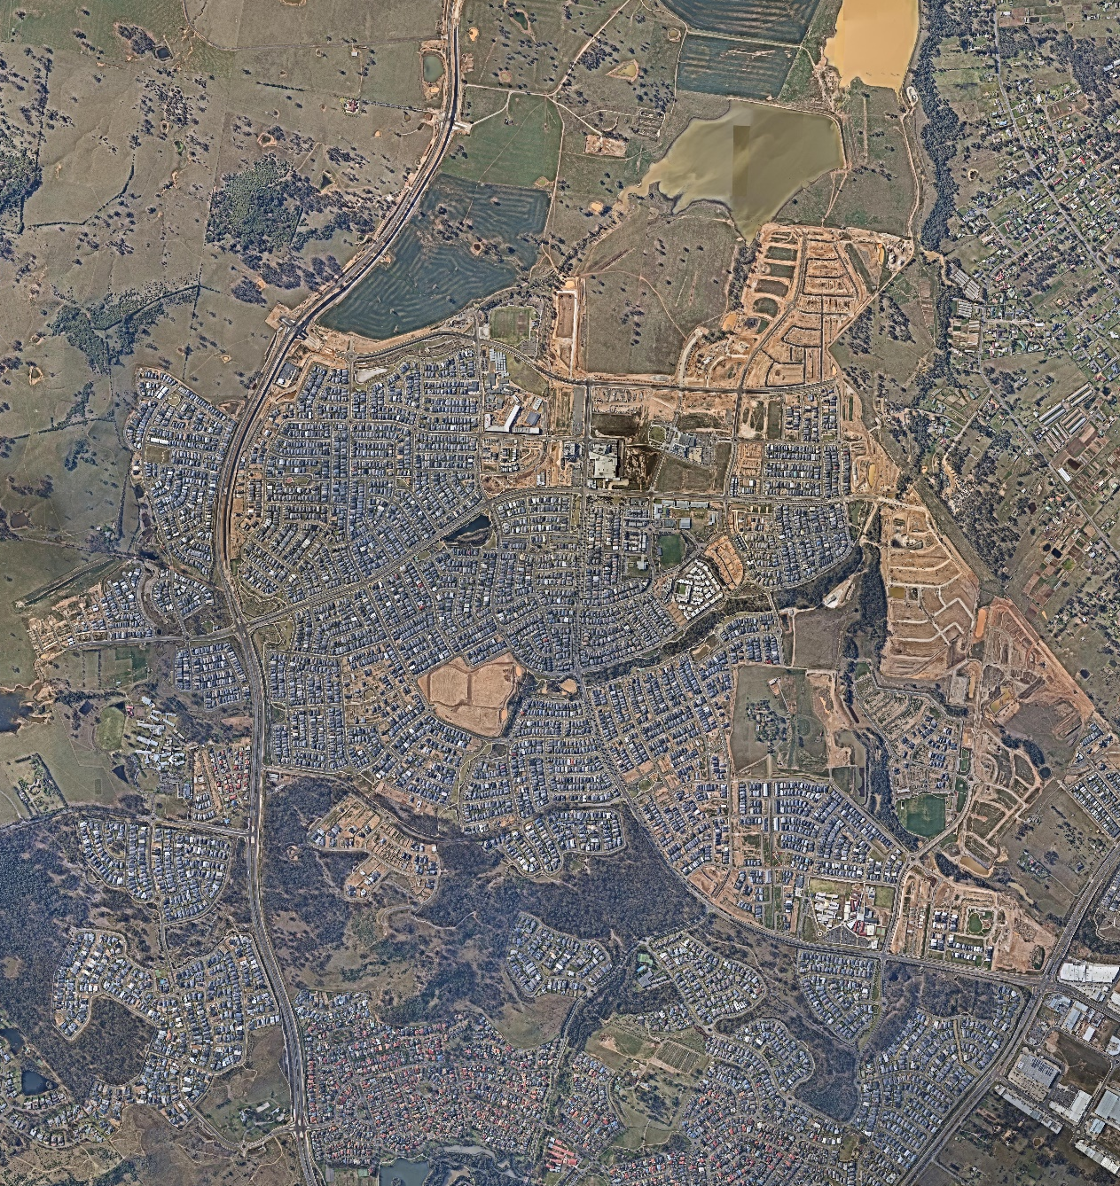
Council Administration Building
Oran Park Podium
Subject Site
Figure 1 – Aerial photo showing location of the subject site in relation to the Camden Council administration building and the Oran Park Podium shopping centre.

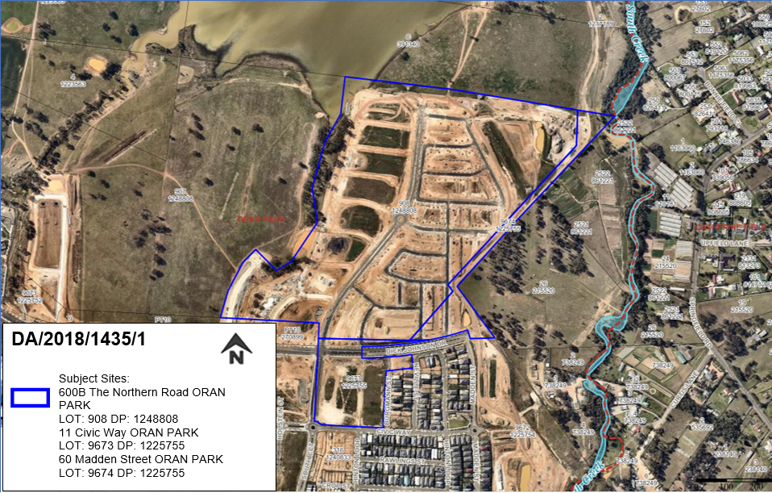
Figure 2 – Subject site map.
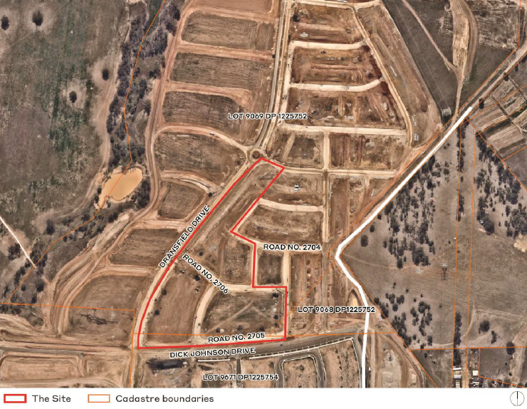
Figure 3 – Area subject to development in relation to adjoining development.

THE SITE

The area subject to development falls across three lots which are commonly known as 600B The Northern Road, 11 Civic Way, and 60 Madden Street, Oran Park and legally described as Lot 908, DP 1248808 and Lots 9673 and 9674, DP 1225755.

A previous development application (DA/2017/1324/1) approved on 2 May 2018 permitted the creation of four super lots, construction of roads, provision of services and civil and landscaping works. The subject application seeks to further develop three of these superlots being unregistered lots 7182, 7183 and 7184. Figure 4 below contains the subdivision plan approved by DA/2017/1324/1.

The development area is bound by the four lane sub-arterial road (Dick Johnson Drive) to the south, a collector road (Dransfield Drive) to the west and approved local roads 2705, 2704 and 2709 to the east and north. Dransfield Drive is built along a ridgeline meaning that generally the site comprises a gradual fall towards the south and east. The site is clear of any vegetation, with all vegetation removed as part of the bulk earthworks approved under a separate development application for bulk earthworks (DA/2017/741/1). There are no significant easements within or nearby the site.

In terms of surrounding development, to the immediate north and east of the site is undeveloped land approved for low density residential development under the same development application which approved the subject site’s super lots (DA/2017/1324/1) with further undeveloped residential zoned land beyond. To the immediate south is the future sub-arterial Dick Johnson Drive which is currently under construction and medium density residential zoned land beyond. The Oran Park town centre and the Camden Council administrative building lie to the south west.

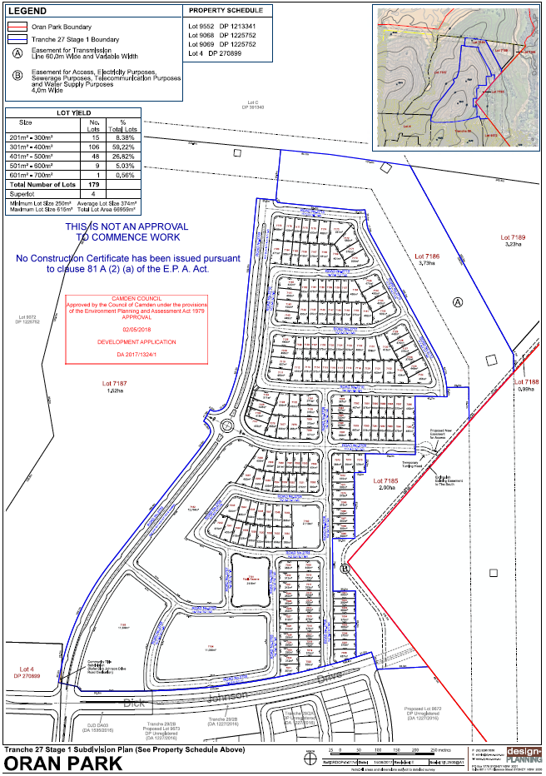
Figure 4 – Subdivision plan approved by DA/2017/1324/1.

ZONING PLAN

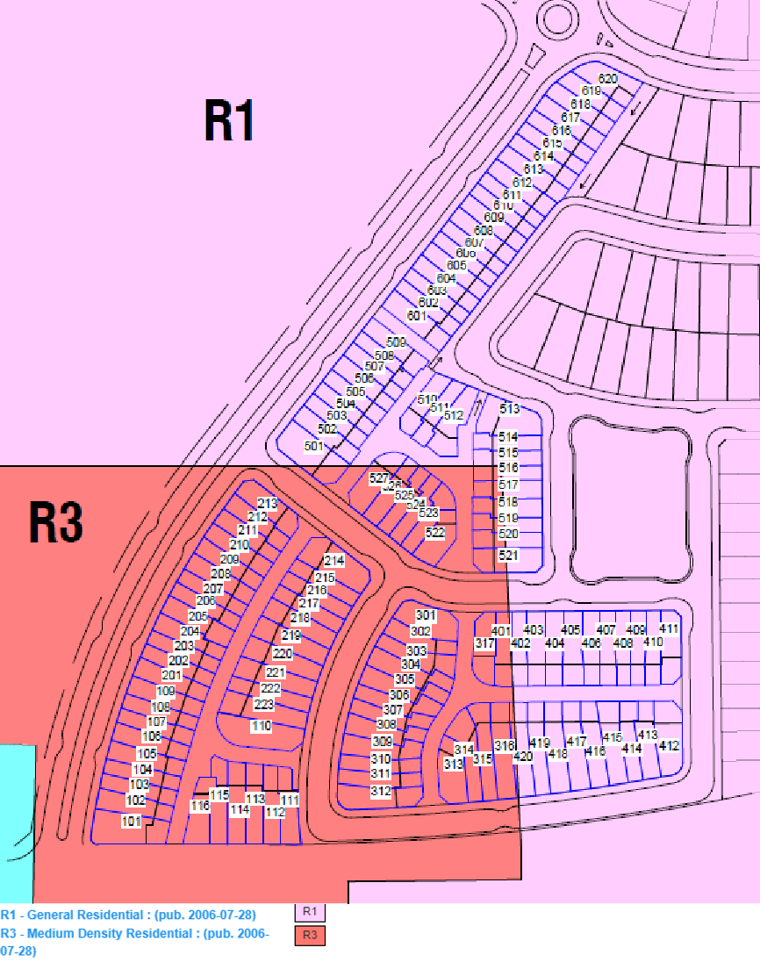
Figure 5 – Zoning map overlay (lots subject to this application outlined in blue).

MASTERPLAN

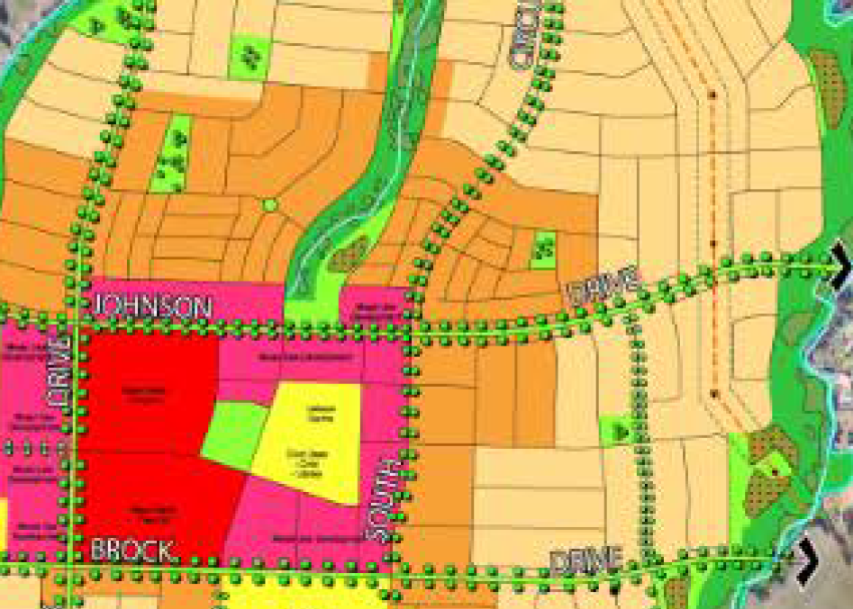
Subject Site
Figure 6 – Extract from Oran Park Indicative Layout Plan showing development site.

HISTORY

The relevant development history of the site is summarised in the following table:

Date | Development
3 October 2017. | Approval of DA/2017/741/1 for bulk earthworks, tree removal and installation of sediment and erosion control measures including four temporary sediment basins
2 May 2018, | Approval of DA/2017/1324/1 for a staged subdivision to create 179 residential lots, 5 residue lots, 4 super lots, a future public reserve, construction of roads, civil works, provision of services, dedication of land and landscaping works

THE PROPOSAL

DA/2018/1435/1 seeks approval for the subdivision and construction of integrated housing development.

Specifically, the development involves:

- Torrens title subdivision of the approved, but not yet registered Lots 7182, 7183 and 7184 into 123 residential lots and 1 public reserve lot,

- Construction of 131 dwellings comprising:

  - 8 dwelling houses,

  - 97 attached dwellings,

  - 18 semi-detached dwellings, and

  - 8 secondary dwellings,

- Construction of five internal laneways to service the development, as well as three shared driveways,

- Cut and fill works to enable the construction of the proposed development,

- Public domain landscaping works to enable the development, including the provision of a new through site landscaped pedestrian link,

- Staging of the development, such that the proposal can be developed over six stages,

- Construction of associated private dwelling landscaping, and

- Construction of associated landscaping and public domain works.

The CIV of the development is $43.3 million.

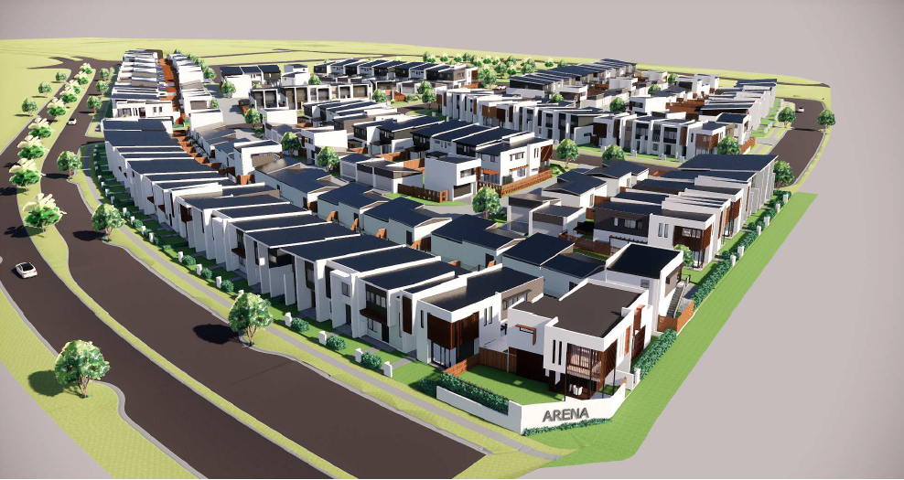
Figure 7 – Three-dimensional render of the proposal.

ASSESSMENT

Environmental Planning and Assessment Act 1979 - Section 4.15(1)

In determining a DA, the consent authority is to take into consideration such of the following matters as are of relevance to the development the subject of the DA:

(a)(i) the provisions of any environmental planning instrument

The environmental planning instruments that apply to the development are:

- State Environmental Planning Policy (State and Regional Development) 2011.
- State Environmental Planning Policy (Sydney Region Growth Centres) 2006.
- State Environmental Planning Policy No 55 - Remediation of Land.
- State Environmental Planning Policy (Building Sustainability Index: BASIX) 2004.
- State Environmental Planning Policy (Affordable Rental Housing) 2009.
- Sydney Regional Environmental Plan No 20 - Hawkesbury-Nepean River.

State Environmental Planning Policy (State and Regional Development) 2011 (SRD SEPP)

The SRD SEPP identifies development that is State significant or regionally significant development.

The Panel is the consent authority for this DA as the CIV of the development is $43.3 million. This exceeds the CIV threshold of $30 million for Council to determine the DA Pursuant to Schedule 7 of the SRD SEPP.

State Environmental Planning Policy (Sydney Region Growth Centres) 2006 (Growth SEPP)

Site Zoning

The site is zoned R1 General Residential and R3 Medium Density Residential pursuant to Appendix 1, Clause 2.2 of the Growth SEPP.

Land Use Definitions

The development is defined as “subdivision”, “dwelling houses”, “semi-detached dwellings”, “attached dwellings” and “secondary dwellings” by the Growth SEPP.

Permissibility

All of the development is permitted with consent in the zones in which it is proposed pursuant to the land use table in Appendix 1 of the Growth SEPP.

Planning Controls

An assessment table in which the development is considered against the Growth SEPP’s planning controls is provided as an attachment to this report.

State Environmental Planning Policy No 55 - Remediation of Land (SEPP 55)

SEPP 55 provides a State-wide planning approach to the remediation of contaminated land.

Clause 7 of SEPP 55 requires the consent authority to consider if the site if contaminated. If the site is contaminated, the consent authority must be satisfied that it is suitable in its contaminated state for the development. If the site requires remediation, the consent authority must be satisfied that it will be remediated before the land is used for the development. Furthermore, the consent authority must consider a preliminary contamination investigation in certain circumstances.

The applicant has submitted a summary of contamination assessment letter that identifies two contamination assessments and one Site Audit Statement (SAS) and Site Audit Report (SAR) relevant to the site. This letter concludes that the site is suitable for the development from a contamination perspective. Council staff have reviewed the letter and corresponding documents, accept their findings and are satisfied that the site is suitable for the development.

A standard contingency condition is recommended that requires any contamination found during construction to be managed in accordance with Council's Management of Contaminated Lands policy.

State Environmental Planning Policy (Building Sustainability Index: BASIX) 2004

The applicant has provided individual BASIX certificates for each dwelling. The relevant water, thermal comfort and energy targets for the Camden Local Government Area have been met. A condition of consent is recommended to ensure the development is carried out in accordance with the specifications of the certificates.

State Environmental Planning Policy (Affordable Rental Housing) 2009

The SEPP aims to provide a consistent planning regime for the provision of affordable rental housing and facilitate the effective delivery of new affordable rental housing.

Development for the purposes of a secondary dwelling must not be consented to if the floor areas exceeds the maximum permitted under an environmental planning instrument. Clause 5.4 of the Growth SEPP specifies a maximum gross floor area of 75 square metres for secondary dwellings.

The application seeks approval for the construction of eight secondary dwellings. All secondary dwellings are consistent with the aims and requirements of the SEPP and have a gross floor area that is less than 75 square metres.

Sydney Regional Environmental Plan No 20 - Hawkesbury-Nepean River (SREP 20)

SREP 20 aims to protect the environment of the Hawkesbury-Nepean River system by ensuring that the impacts of future land uses are considered in a regional context.

The development is consistent with the aim of SREP 20 and all of its planning controls. There will be no detrimental impacts upon the Hawkesbury-Nepean River system as a result of the development. Appropriate erosion and sediment control measures and water pollution control devices have been proposed as part of the development.

(a)(ii) the provisions of any proposed instrument that is or has been the subject of public consultation under this Act and that has been notified to the consent authority (unless the Secretary has notified the consent authority that the making of the proposed instrument has been deferred indefinitely or has not been approved)

Draft Environment State Environmental Planning Policy (Draft Environment SEPP)

The development is consistent with the Draft Environment SEPP in that there will be no detrimental impacts upon the Hawkesbury-Nepean River system as a result of it.

(a)(iii) the provisions of any development control plan

The development control plans that apply to the development are:

- Camden Development Control Plan 2011.
- Oran Park Precinct Development Control Plan 2007.

Camden Development Control Plan 2011 (Camden DCP)

An assessment table in which the development is considered against the Camden DCP is provided as an attachment to this report.

Oran Park Precinct Development Control Plan 2007 (Oran Park DCP)

An assessment table in which the proposed development is considered against the Oran Park DCP is provided as an attachment to this report. Discussion regarding the variations sought to the rear lane setback, upper floor site coverage and building separation controls is outlined below:

Proposed Variation 1 – Rear Lane Setback

The proposed development seeks a variation to Control 10 in Section 3.1.1 - Laneways which requires a maximum setback to the rear lane garage of 2 metres. The developments on 18 of the lots propose rear setbacks greater than 2 metres.

Applicant’s Variation Justification – Rear Lane Setback

The applicant made the following submission in support of the proposed variation:

“A standard laneway setback of 1.15m has been adopted to all two way laneways, and a standard laneway setback of 0.9m has been adopted for all one way laneways. This has been developed in accordance with Council in order to allow for Council’s waste vehicles to navigate the laneway. Detailed sections demonstrating this have been provided.

In addition to the above, other reasons for the provision of additional laneway setbacks in the development include:
- provision of greater articulation beneath secondary dwellings / retreat bedrooms (e.g. Lots 205, 405);
- articulation of laneways to avoid ‘walls of garages’ (e.g. Lot 209);
- enable the preservation of corner lot splays and sight lines (e.g. Lots 214, 501);
- account for shared driveways (e.g. Lots 504-509, 514-517); and
- resolve laneway curvature issues (e.g. Lots 304-309).
A range of measures have been proposed on a proposal wide basis in order to ensure that illegal vehicle storage will not occur in the laneway.

Car parking in these locations will be predominantly avoided through the use of landscaping, which will avoid the provision of large unencumbered areas of paving by breaking up car parking with vegetated area. The proposed use of articulation reinforces this intended design outcome, with many of the garage designs above comprising only minimal setback above the control, and not being suitable for on-street vehicular parking.

The changes in garage depth between garages along the laneway will also contribute to ensuring that on-street parking will not occur within the driveway hardstands, in that there will not be the provision of a long line of garages with significant setbacks, meaning that vehicles cannot fit in the spaces provided.

It is noted that the double garage paved areas proposed have a maximum width of 4.8m, which falls short of a standard 5.5m parking space, and would be inadequately sized to park a car in.

This range of measures, when combined, are considered sufficient to deter people from illegally parking in the laneway, and accordingly the proposed rear setback carries sufficient protections to warrant approval.”

Variation Assessment – Rear Lane Setback

The developments on 18 of the 123 lots, or 14.6%, propose a rear lane setback greater than 2 metres. The non-compliance that is proposed on lots 101, 110, 115, 116, 214, 220, 223, 312, 314, 400, 405, 411, 412, 415, 501, 513, 523 and 527 is considered acceptable for the following reasons:

- The non-compliances are primarily caused by the required corner lot splays, the inclusion of secondary dwellings and retreats above the rear loaded garages and the increased setback requirements to service the laneways with Council’s waste collection vehicles.

- To allow Council’s waste collection vehicles to service the laneways, a minimum setback of 0.9m for one way laneways and 1.15m for two way laneways is required and has been adopted. This is greater than the required minimum setback of 0.5m detailed in the DCP.

- Where habitable rooms are proposed above the garages of these lots, balconies have been provided that project beyond the garage door below. The inclusion of habitable rooms and balconies is a benefit to the development as it increases the overall level of passive surveillance in the laneways.

- The control acknowledges that larger setbacks up to 2 metres may be permitted to allow for balconies. However, this is based on the minimum rear lane setback of 0.5m. Given that greater setbacks are required to allow waste collection, it can be expected that the setback may exceed 2 metres to provide adequate balconies.

- The projecting balconies and the occasional increased setback provides articulation to both the individual buildings and the laneway as a whole and therefore avoiding the appearance of long rows of garages.

- The laneway configuration and location of garages is orderly and minimises ambiguous spaces to minimise the opportunities for illegal parking and other unintended uses. Both the width and the length of the hard stand area in front of the garages is less than 5.5 metres further reducing the potential for illegal parking within the laneway. Conditions are recommended to provide no stopping signage within the laneways. The use of landscaping and a small number of bollards is proposed to further reduce unintended uses in the laneways.

- The proposal continues to meet the objectives of this control in that it reduces the dominance of garages and enables garbage collection.

Proposed Variation 2 – Site Coverage

The proposed development seeks a variation to Control 2 in Section 7.6.5 - Dwelling Height, Massing and Siting which requires a maximum upper level site coverage of 40%. The dwellings on lots 405, 411 and 601 do not comply with this control as they propose an upper level site coverage of 42%, 41% and 41% respectively.

Applicant’s Variation Justification – Site Coverage

The applicant made the following submission in support of the proposed variation:

“A variation to Provision 7.6.5 is therefore sought for these allotments, with the following points noted in support of the variation:

- The proposed retreat rooms maintain the intention of secondary / studio dwellings, by providing additional surveillance over surrounding areas. This includes laneways, as well as the through site link at Stage 5 of the proposal. In each of these cases, the ‘retreats’, despite not constituting a separate legal dwelling, will continue to provide natural surveillance benefits to the surrounding areas.

- The proposed retreats have been generally designed in accordance with the controls for secondary dwellings, resulting in a building form which is appropriate within the surrounding context.

- The proposed retreats continue to contribute to the provision of further dwelling diversity, with the retreat rooms positively contributing to the amenity and experience of the allotments on which they are located.

- All of the proposed lots have been designed to meet the intent of Provision 7.6.5, with the additional retreat bulk of Lots 405, 411 and 510 overshadowing the respective laneways. Additionally, Lot 509 overshadows garages only, and Lot 601 overshadows the through site link. The impact of this is that none of the retreats have an adverse solar impact on the PPOS of surrounding dwellings.

- All of the proposed retreats have also been oriented towards the respective street / laneway frontages, in order to minimise any potential privacy impacts.”

Variation Assessment – Site Coverage

Since lodgement, the applicant has amended the application to reduce the number of non-compliant lots from five to three. The minor non-compliance on Lots 405, 411 and 601 is considered acceptable for the following reasons:

- The minor variation to this control is driven by the inclusion of habitable rooms above the rear loaded garages (noted as retreats on the plans and elsewhere in this report). These rooms will play an important role in increasing passive surveillance of the laneway and, in the case of lot 601, the public reserve lot and pedestrian path between stages 5 and 6.

- The orientation of these lots is such that the rear garages are located at the southern end of the lot minimising the impact of the proposal on the solar access of adjoining lots.

- The scale of the development is appropriate given the medium density nature of the site. The minor increase in bulk will not cause any significantly impacts on residential amenity or the public domain.

Proposed Variation 3 – Building Separation

The proposed development seeks a variation to Control 11 in Section 7.7.2 - Secondary Dwellings, Studio Dwellings and Dual Occupancies which requires a minimum separation of 5 metres between the upper floor of a principal and secondary dwelling. Lots 101 and 214 propose building separations of 4.5m and 3.9m respectively.

Applicant’s Variation Justification – Building Separation

The applicant made the following submission in support of the proposed variation:

“This proposed outcome is considered acceptable despite the proposed variation on the basis of the following:

- The proposed secondary dwellings achieve Objective (a) of the control, given that they will further increase the provision of diverse housing typologies in a location which benefits from close proximity to high quality services, access and public open space.

- The proposed secondary dwellings achieve Objective (b) of the control by providing additional housing in the context of Oran Park.

- The proposed dwellings achieve Objective (c) by providing an innovative solution across Tranche 27 of Oran Park, which works to enable the provision of a diverse array of innovative housing solutions which cater to a range of different residential lifestyles and needs.

- The proposed dwellings achieve Objective (d) by providing natural surveillance to the laneway network at Tranche 27.

- Lots 101, 213, 214 and 317 comprise ‘block end’ lots of each respective dwelling set and provide additional supervision over the nearby streets / laneways.

- Secondary dwellings, as opposed to strata titled studio dwellings, remain on the same title and fully under the control of the principal dwelling owners. Accordingly, the maintenance of privacy between the dwelling house and the secondary dwelling is of less importance than if a studio dwelling were to be provided at the site. On this basis, the provision of these dwellings is considered acceptable in the context of the site.”

Variation Assessment – Building Separation

Since lodgement, the applicant has amended the application to reduce the number of non-compliant lots from five to two. The variation to the building separation control for the remaining two lots, lot 101 and lot 214, is considered acceptable for the following reasons:

- Both lots are located on corners and are therefore impacted by corner splays. Greater front and rear setbacks are required to maintain sight lines. The secondary dwellings on these corner lots play an important role in providing casual surveillance over both the laneway and the secondary street and their removal would adversely impact on the development.

- Lots 101 and 214 propose lot sizes of 397.1m² and 388.2m² respectively. This is above the average lot size of 247.3m² for all proposed lots and allows satisfactory principle private open space to be provided to both dwellings.

- The above average lot size and east-west orientation of each lot allows for increased solar access and a high level of residential amenity. The building separation control is needed to provide an adequate amount of solar access to principal private open space between two x two storey buildings, compliant solar access to the principal open space of both lots is achieved.

- The inclusion of secondary dwellings on these lots, and the resulting non-compliance, will not significantly impact on adjoining dwellings. Adjoining lots achieve minimum solar access requirements and the secondary dwellings have been designed to minimise overlooking and privacy concerns.

- The proposal is considered capable of complying with the provisions of the National Construction Code subject to the recommended conditions.

(a)(iiia) the provisions of any planning agreement that has been entered into under section 7.4, or any draft planning agreement that a developer has offered to enter into under section 7.4

The site falls within land which is subject to the Oran Park Urban Release Area Voluntary Planning Agreement (Oran Park VPA), signed in September 2011.

The Oran Park VPA provides for infrastructure and associated facilities within the Oran Park Town project, in lieu of payments under the Oran Park & Turner Road Precinct Section 94 Contributions Plan. The timing of the delivery of contribution items generally relates to the amount of registered residential lots.

The Proposal is consistent with the land use and development outcomes, infrastructure/facilities provision and staging outcomes prescribed under the Oran Park VPA. The proposed development will not trigger any deliverables nor impinge on the capacity of any of these requirements to be delivered.

(a)(iv) the regulations (to the extent that they prescribe matters for the purposes of this paragraph)

The Environmental Planning and Assessment Regulation 2000 prescribes several matters that are addressed in the conditions attached to this report.

(b) the likely impacts of the development, including environmental impacts on both the natural and built environments, and social and economic impacts in the locality

As demonstrated by the assessment, the development is unlikely to have any unreasonable adverse impacts on either the natural or built environments, or the social and economic conditions in the locality.

Traffic Impacts

At the time of lodgement, the application proposed the connection of Driveway 2 and 3 through to ‘Road No. 2704’. Through the assessment process, the application was amended to remove these through connections due to the unacceptable impacts on the pedestrian network and the potential for it to be used as a ‘rat run’ in the future.

The amended design of these shared driveways includes turning heads. The turning heads are significant in size and will result in undesirable visual impacts and a loss of area of the Public Reserve. Council has reviewed the proposal and determined that the turning heads are not required for Driveway 2 and 3 as they are less than 30 metres in length and only service a small number of garages. Furthermore, waste collection vehicles are not required to access these shared driveways as all waste collection is conducted from roads. As such, a condition is recommended to remove the turning heads provided for shared driveways 2 and 3.

The applicant has submitted a traffic report and supporting information in support of the DA. The report and supporting information demonstrate that the development will not have a significant negative impact upon the surrounding road network and the operation of surrounding intersections. Council staff have reviewed the report and supporting information and agree with their conclusions.

‘Fronts to Backs’ Garages Fronting Local Street

The rear loaded garages of lots 601 to 612 adjoin a local road instead of a laneway. While this does not introduce any non-compliance, it is important to consider the impact on passive surveillance and the visual amenity of the public domain.

Future adjacent residential lots will be bound by planning controls to limit secondary street fencing and include habitable rooms that overlook primary and secondary streets. This and the retreat above lot 601 will assist in increasing the level of casual surveillance of the road.

Furthermore, the applicant has amended the application to include a greater degree of articulation (shown in Figure 8) which will contribute to creating an interesting streetscape character.

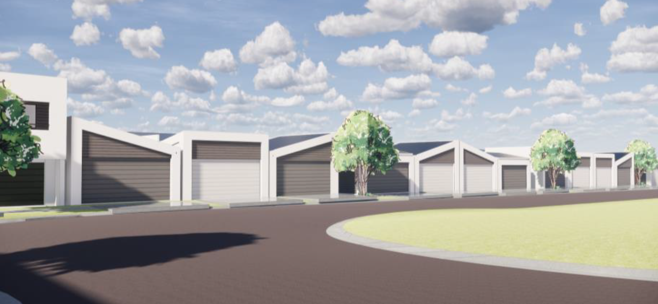
Figure 8 – View of rear loaded garages of lots 601 to 612 from local road ‘Road No. 2704’.

(c) the suitability of the site for the development

As demonstrated by the above assessment, the site is considered to be suitable for the development.

(d) any submissions made in accordance with this Act or the regulations

The DA was publicly exhibited for a period of 14 days in accordance with Camden Development Control Plan 2011. The exhibition period was from 16 to 29 January 2019. No submissions were received.

(e) the public interest

The public interest is served through the detailed assessment of this DA under the Environmental Planning and Assessment Act 1979, the Environmental Planning and Assessment Regulation 2000, environmental planning instruments, development control plans and policies. Based on the above assessment, the development is consistent with the public interest.

EXTERNAL REFERRALS

The external referrals undertaken for this DA are summarised in the following table:

External Referral | Response
NSW Rural Fire Service. | A bush fire safety authority is required as subdivision of bush fire prone land is proposed. Parts of the parent lots are mapped as bush fire prone land however these areas are greater than 100 metres from the development site.  The Rural Fire Service issued General Terms of Approval and a Bush Fire Safety Authority 5 February 2019 without any specific conditions.

A standard condition that requires compliance with the external referral responses is recommended.

FINANCIAL IMPLICATIONS

This matter has no direct financial implications for Council.

CONCLUSION

The DA has been assessed in accordance with Section 4.15(1) of the Environmental Planning and Assessment Act 1979 and all relevant instruments, plans and policies. The DA is recommended for approval subject to the conditions attached to this report.

RECOMMENDED
That the Panel approve DA/2018/1435/1 for an integrated housing development at 600B The Northern Road, 11 Civic Way, and 60 Madden Street, Oran Park subject to the conditions attached to this report.

